APIs are languages that allow applications to exchange information. Today, there are many possible technologies that can be used to design and implement APIs (REST, SOAP, GraphQL, …). But before settling on one technology, it is also important to decide which API style to use. In this introduction, we have a brief look at the 5 major API styles, on which different API technologies (REST, SOAP, …) are based

* **Tunnel Style**: An API is a collection of functions that can be invoked remotely. We call procedures within computer program.
  + XML-RPC
  + JSON-RPC
  + SOAP
  + gRPC

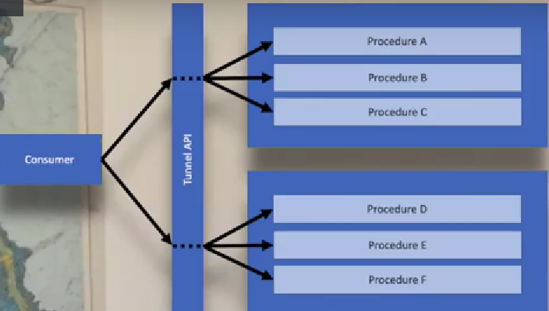

* **Resource Style**: An API is a collection of resources that allow various kinds of interactions. We expose URL to endpoints which describe items (users, orders, …)
  + REST

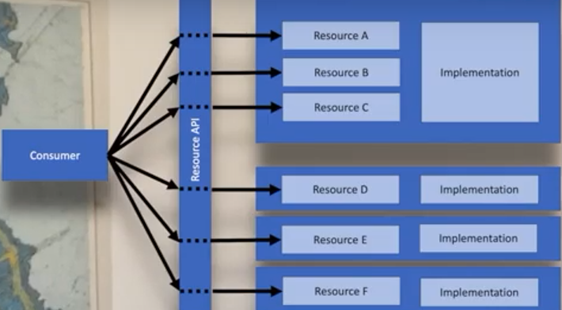

* **Hypermedia Style**: An API is a collection of interlinked resources just like resources on the Web. It’s based on resources, but it also links resources with each other
  + REST (If you design it properly and as REST has been defined by its creator, REST always is Hypermedia. But most APIs out there that claim to be REST will be HTTP-based and provide resources, but they will not use Hypermedia. So in practice most APIs that claim to be REST are using the Resource style.

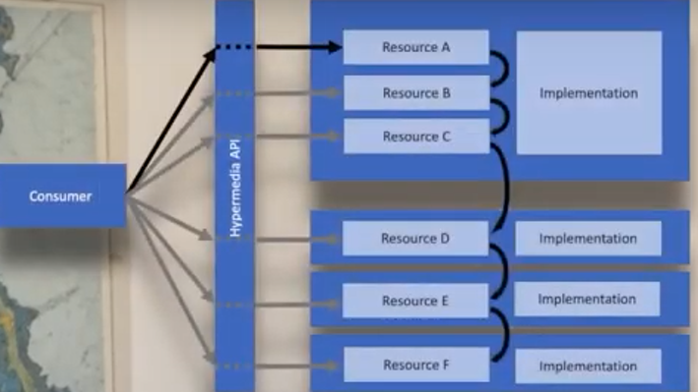

* **Query Style**: An API exposes a structured data model that can be queried and updated with a generic query language.
  + GraphQL

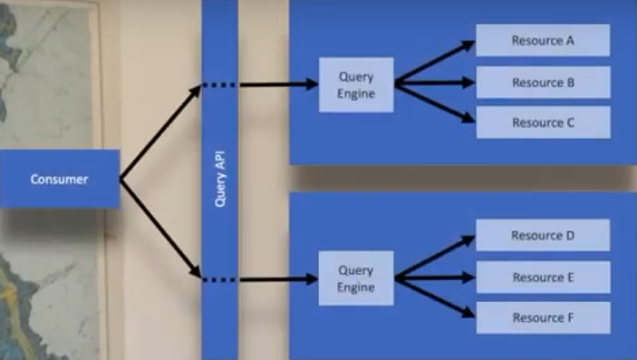

* **Event-based Style**: An API is a collection of events that are published by providers and can be subscribed to by consumers. We have subscription model where customer subscribes for event and then server send events as soon as condition is reached
  + WebHooks
  + Kafka / RabbitMQ (Microservices communication)

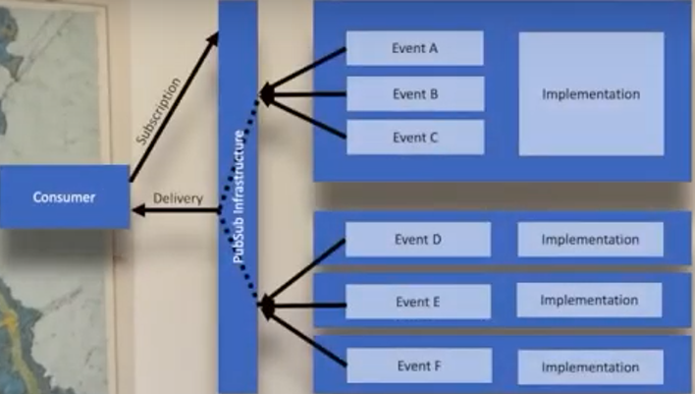

Другой взгляд на стили API

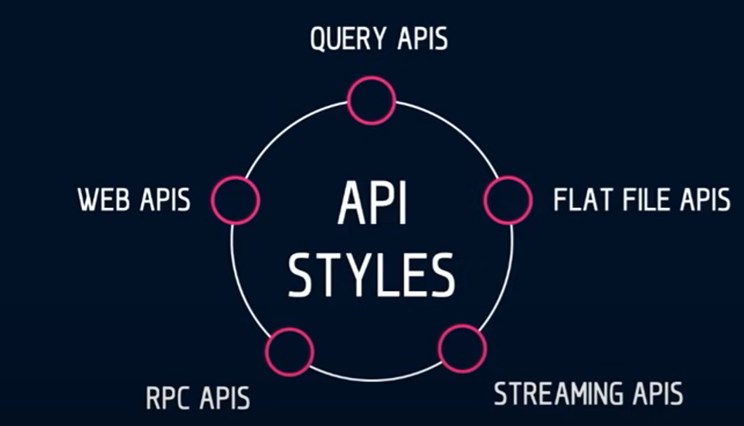

**Query API**

* GraphQL

**Flat File API**

* EDA (Electronic Data Interchange)

**Streaming API**

* WebSockets
* Kafka

**RPC API**

* XML-RPC
* JSON-RPC
* SOAP
* gRPC

**WEB API**

* REST

RPC стили могут быть переданы как через 7 уровень OSI – HTTP, FTP, …

Так и через 5 уровень, не используя HTTP. По сути SOAP может быть передан и через HTTP, в теле. А может быть передан вообще не используя HTTP